Project Report: Retail Sales Performance Analytics using SQL

Objective
The objective of this project was to design an end-to-end SQL workflow that transforms retail sales data into actionable business insights. The project demonstrates data integration, aggregation, and performance analytics using realistic target modelling and ranking logic.

Dataset & Design
The dataset was adapted from a cleaned retail sales CSV file originally analyzed in Excel.
It was imported into MySQL Workbench as three tables:
- orders: detailed transaction data (dates, sales, profit, discounts, salesperson, etc.)
- returned: list of returned orders
- people: salesperson region mapping
Relationships were joined in a consolidated view vw_orders_full, enabling integrated analysis.
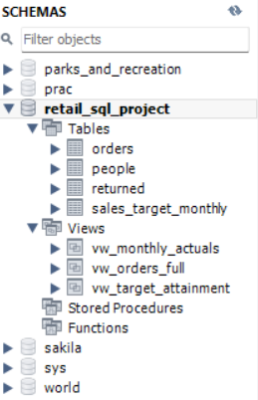
Figure 1: Database schema showing base tables and analytical views.

Analytical Process
Step 1: Data Integration (vw_orders_full)
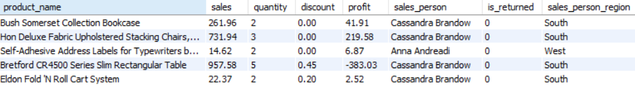
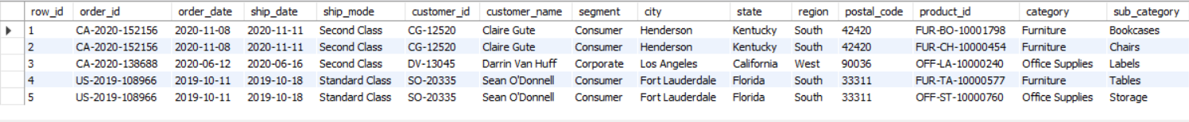
Created a unified analytical view combining the three tables (orders, people, and returned).
Added a flag is_returned to mark returned orders.
Figure 2: Integrated view combining orders, returns, and people with is_returned flag.

Step 2: Monthly Aggregation (vw_monthly_actuals)
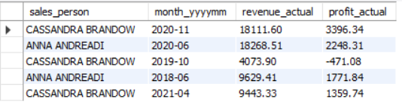
Built a summarized view that aggregates total monthly sales and profit per salesperson.

Figure 3: Monthly aggregated sales and profit per salesperson.

Step 3: Target Generation (sales_target_monthly)
Simulated business targets by setting each salesperson’s next month target as +3% of their previous month’s actuals using the vw_monthly_actuals data.
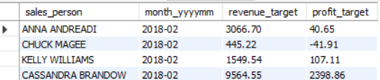

Figure 4: Synthetic monthly targets generated (+3% growth on previous month’s actuals).
Step 4: Performance Analytics (vw_target_attainment)
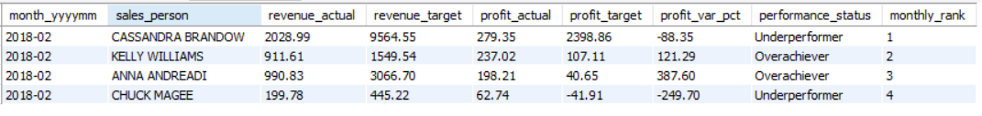
Built a view combining actuals and targets to calculate variance %, classify performance status, and assign monthly rank.
Figure 5: Consolidated performance analysis with variance, ranking, and status labels.

Step 5: Business Insights Extraction
Generated business-level KPIs such as total sales, profit, and return rate.
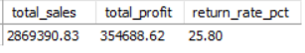
Figure 6: Key performance indicators – sales, profit, and return percentage.

Step 6: Monthly Trends
Visualized monthly growth trend across the dataset.
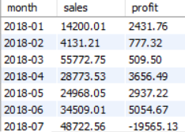
Figure 7: Monthly trend analysis of total sales and profit.

Key Insights
- Average return rate was 25.80% (calculated from Screenshot 6).
- All four salespersons exceeded targets after monthly adjustment (+3%), showing consistent performance.
- Dynamic target modeling and ranking logic can scale to hundreds of salespersons with minimal code change.

Challenges & AI-Driven Solutions
Challenge | AI-Assisted Solution
Error 1046 (No Database Selected) | Used AI guidance to specify schema context with USE retail_sql_project;.
Duplicate key errors while generating targets | AI suggested normalization using TRIM() and grouping logic.
Unrealistic results (all underperformers) | AI helped identify logical flaw (targets from same month) and fix by shifting targets to next month.
Report formatting and portfolio presentation | Used AI to structure professional-level report with screenshot mapping.

Example of AI-assisted debugging and problem-solving:
https://chatgpt.com/g/g-p-68ef56d465588191b74386d62cbae9d5-da-project/shared/c/68ff669b-15d8-8326-8e73-ca6a8ebe8bc7?owner_user_id=user-xxZGJzgMbb1oJd4jdUbsPGkE

Skills Demonstrated
- SQL (joins, aggregations, window functions, views, indexing)
- Data cleaning & integration
- Business logic simulation
- Analytical storytelling
- Efficient reporting and visualization preparation
- AI-assisted problem solving and debugging

Outcome
Delivered a working SQL analytics pipeline with end-to-end integration, aggregation, and insight extraction.
The project demonstrates technical proficiency and business acumen aligning data analytics with realistic performance management scenarios.

Tools Used
- MySQL Workbench 8.0 CE (database & visualization)
- Microsoft Excel (data preparation)
- ChatGPT (AI assistant) (debugging & project design)
Optional Future Extension
If you wish to extend this project:
- Connect MySQL to Power BI or Tableau using the vw_target_attainment view.
- Build a dashboard showing KPIs, trend charts, and sales performance variance.

Conclusion
This project demonstrates how SQL can turn raw retail data into actionable insights.
By integrating multiple tables, modeling monthly targets, and ranking salesperson performance, I built a complete analytics pipeline inside MySQL Workbench.
It highlights strong skills in SQL, business logic, and efficient reporting—supported by AI-assisted problem solving for real-world accuracy.

